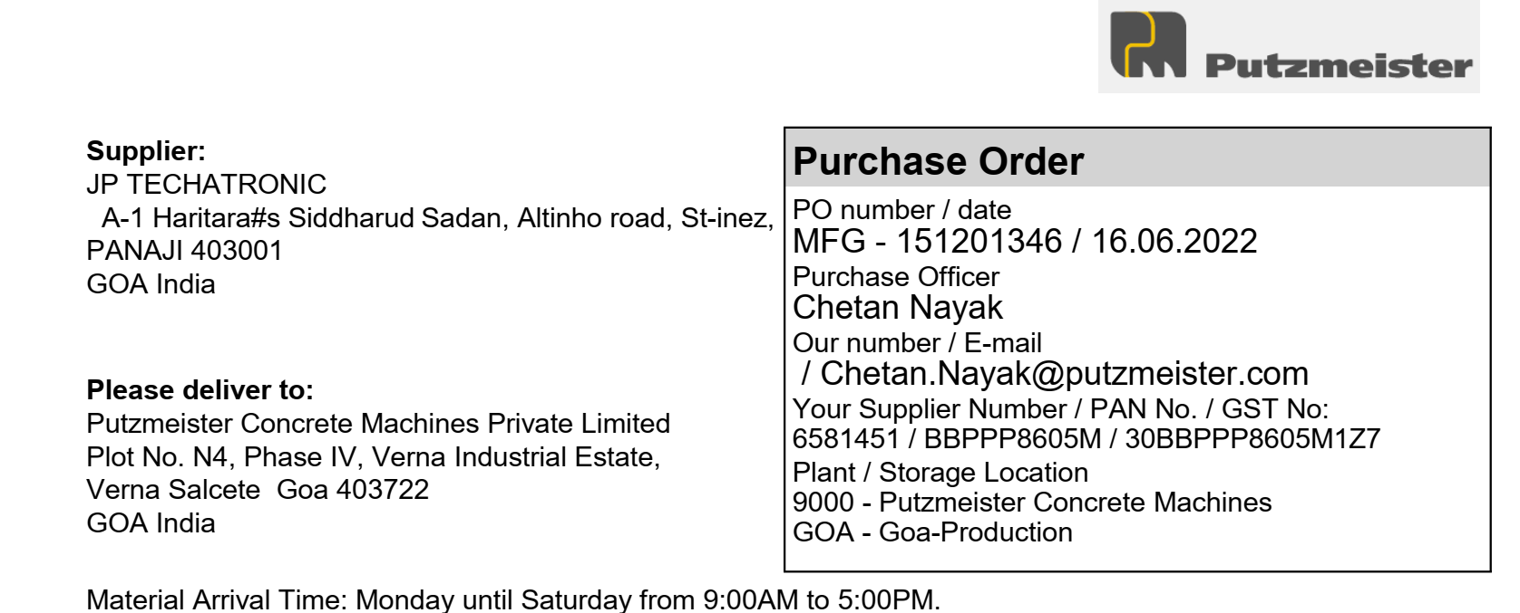

|  |  |  |  |  |  |  |
| --- | --- | --- | --- | --- | --- | --- |
| **Sr. No** | **Material** | **Description** | **Quantity** | **Unit** | **Price Per Unit** | **Net Price (INR)** |
| 1 | 615181 | INDUSTRIAL BELL_225mm | 3 | PCS | 2400 | 7200 |
|  |  |  |  | CGST | 9% | 648 |
|  |  |  |  | SGST | 9% | 648 |
| Delivery Schedule |  |  |  |  |  |  |
| Date | 31.07.2022 |  |  |  |  |  |
| 2 | 719381 | Monochrome laserjet printer CanonLBP6030BJ | 5 | PCS | 8299 | 41495 |
|  |  |  |  | CGST | 9% | 3734.55 |
|  |  |  |  | SGST | 9% | 3734.55 |
| Delivery Schedule |  |  |  |  |  |  |
| Date | 01.08.2022 |  |  |  |  |  |
| 3 | 616026 | Screw Conveyor Bellow_Dia | 10 | PCS | 5614 | 56140 |
|  |  | 224x4x500mm |  | CGST | 9% | 5052.6 |
|  |  |  |  | SGST | 9% | 5052.6 |
| Delivery Schedule |  |  |  |  |  |  |
| Date | 01.08.2022 |  |  |  |  |  |
|  |  |  |  | Basic Total | | 104835 |
|  |  |  |  | Central GST | | 9435.15 |
|  |  |  |  | State GST | | 9435.15 |
|  |  |  |  | **Total In INR** | | **123705.3** |

Amount In Words:

One Lakh Twenty Three Thousand Seven Hundred Five Rupees and Thirty Paise.



It is necessary to put the Putzmeister order number on every invoice.

Terms and conditions applied.



